**Application – Get There   
Deliverable 1**

Functional Model – 1st Iteration

1. Epic Stories
   1. To successfully navigate around WPI including interior buildings
2. User Stories
   1. As a student I want to get to tech suite 217 to attend my Software Engineering meeting.
   2. As a student I want to reach Kaven from the campus center to attend my Civil Engineering Class
   3. As a student I want to reach the gym to attend my basketball class.
   4. As a non-WPI student I want to find the Admissions Department to find campus tours.
3. Scenarios

**Building to building**

Professor Frank is new to WPI. His lecture ended in Atwater Kent. He now needs to find the Campus Centre to buy his lunch.

Professor Frank pulls up the application to navigate through WPI on his laptop. He searches “Campus Centre” and sets it as his destinations. The application displays the campus map with a drawn path from Atwater Kent to the Campus Centre. He takes a picture of the map with his mobile phone and uses it to navigate to the Campus Center.

**Room to room**Bob, sitting in his physics class looks at his schedule and sees that he has a lab on the same floor following class. Bob is a freshman and does not know where anything is.  
Bob, launched the WPI navigation application his computer and enters in his current room. He then searches for the lab room number and selects “route”  
The application displays a map with the route from his class to his lab.

1. User Cases

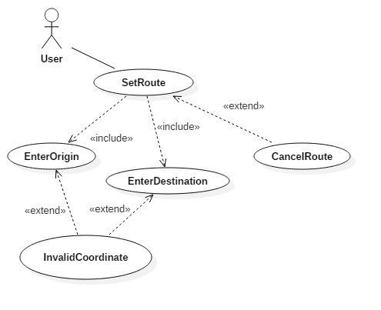

**Figure 1**

Textual Description  
Name: SetRoute  
Participating Actor: User  
Entry Condition: EnterDestination, EnterOrigin  
Exit Condition: Arrive at location  
Flow of Events:   
                User inputs locations  
                User is given map  
                User walks to location  
Alternate Flow of Events:  
InvalidCoordinate:  
User inputs invalid location  
Requests the User to check the input and re-enter the destination

CancelRoute:  
The User cancels the route selection process and closes the application

Survey Results and Analysis

The demography of our survey is as shown below:

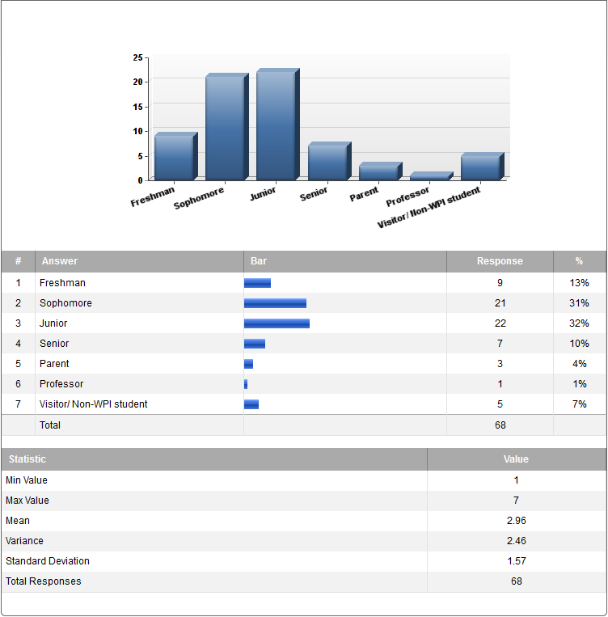

**Figure 2**

Our survey was directed mainly towards the WPI population (*Figure 2*). The survey was distributed over social media and via email to various aliases. We received 68 responses in total with varying opinions. Our questions requested the end user to indicate which features planned by the management team would be necessary and useful. The results of which are shown in *Figure 2.*

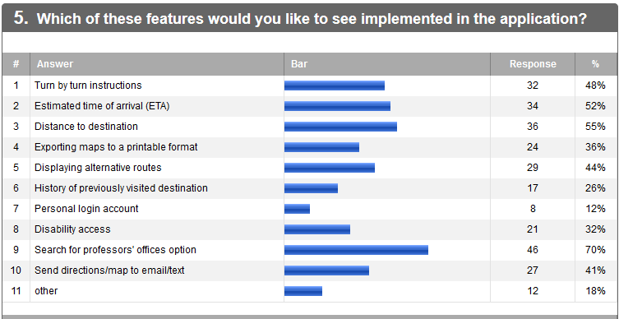

**Figure 3**

Since WPI is a small campus the need for the application wasn’t encouraged by most people. The encouragement we did receive mostly gravitated towards a mobile version of the application.

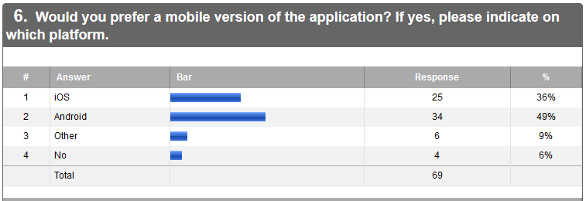

**Figure 4**

Project Management

|  |  |  |
| --- | --- | --- |
| **Position** | **Lead** | **Back up** |
| Project Manager | Parnas, Lumbini | Peterson, Paul W |
| Product Owner | Sullivan, William | Chaves, Jefferey J. |
| Lead Software Developer | Peterson, Paul W | Touma, Jean Marc A |
| Graphics Engineer | Ruggiero, Alexander N | Parnas, Lumbini |
| Test Engineer | Touma, Jean Marc A | Griffin, Christopher S |
| Documentation | Chaves, Jefferey J. | Kaiser, Joseph T |

Software and Communication Tools

|  |  |
| --- | --- |
| **Software Tools** | **Communication Tools** |
| Github/Git | Slack |
| Eclipse | E-mail - Outlook |
| StarUML |  |
| Photoshop/GIMP |  |
| Source Tree |  |

Salary Distribution:

|  |  |  |
| --- | --- | --- |
| **Developer** | **Salary (Total 90W)** | **Contribution for the week** |
| Chaves, Jefferey J. | 11W | Brainstorm, User Cases, Survey Distribution, User Case Diagrams |
| Griffin, Christopher S | 11W | Brainstorm, User Cases, Survey Distribution, User Case Diagrams |
| Kaiser, Joseph T | 11W | Brainstorm, User Cases, User Case Diagrams, Survey Distribution |
| Parnas, Lumbini | 13W | Scheduling Meetings/Coordinating, Brainstorm, Scenarios, Survey |
| Peterson, Paul W | 11W | Brainstorm, User Cases, Survey Distribution, Textual Description |
| Ruggiero, Alexander N | 11W | Brainstorm, User Cases, Working on the Logo for app, Survey Distribution |
| Sullivan, William | 11W | Brainstorm, User Cases, Scenarios, Survey Distribution |
| Touma, Jean Marc A | 11W | Survey, User Cases and Diagrams, Slack set up for the team. |